REQUIREMENTS ANALYSIS DOCUMENT  
for  
APPOINTMENT MANAGEMENT SYSTEM

1.0

07.11.2025

**Prepared by**

Bilgenur Türkel

Musab Kardeş

Ömer Faruk Olkay

Rabia Çerçi

Tayyip Soner Tekin

TABLE OF CONTENTS

1 Introduction 3

1.1 Purpose of the system 3

1.2 Scope of the system 3

1.3 Objectives and success criteria of the project 3

1.4 Definitions, acronyms, and abbreviations 4

1.5 References 4

1.6 Overview 4

2 Current system 4

3 Proposed system 4

3.1 Overview 4

3.2 Functional requirements 5

3.3 Nonfunctional requirements 9

3.3.1 Usability 9

3.3.2 Reliability 9

3.3.3 Performance 9

3.3.4 Supportability 10

3.3.5 Implementation 10

3.3.6 Interface 10

3.3.7 Packaging 11

3.3.8 Legal 11

3.4 System models 11

3.4.1 Scenarios 11

3.4.2 Use case model 19

3.4.3 Object model 20

3.4.4 Dynamic model 20

3.4.5 User interface 24

4 Glossary 36

# Introduction

## Purpose of the system

The primary purpose of this project is to design and develop a web and mobile platform for service-based companies to manage their appointments, employees, services and resources efficiently. Many companies currently rely on manual methods or multiple disconnected tools, which can lead to scheduling conflicts, inefficient resource allocation, and poor communication with customers. This system will solve these problems by providing a single, reliable platform for all scheduling and management tasks, thereby improving operational efficiency and client satisfaction.

## Scope of the system

The system is a multi-tenant application that will support four distinct user roles with specific permissions: Super Admin, Branch Manager, Employee, and Customer.

The scope of the system includes the following core functionalities:

* **Super Admin:** Performs CRUD operations for companies, and branch managers.
* **Branch Manager:** Performs CRUD operations for employees, manages services, assigns services to employees, manages resources, and views employee calendars and usage reports.
* **Employee:** Views schedules, and manages appointment requests.
* **Customer:** Views available services and resources, optionally selects a specific employee, books appointments in available time slots and manage the appointment.
* **Core Features:** The system includes comprehensive calendar management, modules for service and resource management, and a notification system for appointment confirmations, reminders, and cancellations.

## Objectives and success criteria of the project

**Objectives:**

* To develop a user-friendly platform that simplifies the appointment booking process for customers.
* To reduce the administrative workload for Branch Managers and Employees by automating scheduling tasks.
* To eliminate scheduling conflicts, such as double bookings, by accurately filtering available time slots.
* To provide clear and accessible calendar views tailored to the permissions of each user role.

**Success Criteria:**

* A Customer can successfully book a new appointment without conflicts, and the time slot becomes unavailable.
* An Employee can log in, view their daily appointments, and approve or deny a pending request.
* A Manager can successfully create a new service and assign it to an Employee.
* A Customer receives an email confirmation immediately after their appointment request is approved.
* The system correctly restricts access based on user roles (e.g., an Employee cannot access Manager-level functions).

## Definitions, acronyms, and abbreviations

* **CRUD:** An acronym for Create, Read, Update, and Delete. These are the basic operations for managing data.
* **Customer:** The end-user who books an appointment.
* **Employee:** The staff member who provides the 0service for the appointment.
* **Branch Manager:** The user who manages employees, services, and resources for a company.
* **Super Admin:** The highest-level administrator, who manages the entire system and all businesses.

## References

- Object-Oriented Software Engineering, Using UML, Patterns, and Java, 3rd Edition, by Bernd Bruegge and Allen H. Dutoit, Prentice-Hall, 2010, ISBN 10: 0136066836.

- Headfirst Design Patterns: Building Extensible and Maintainable Object Oriented Software, 2nd Edition, O'Reilly Media, 2020. introduction.

## Overview

This document outlines the plan for the appointment management system. **Section 1** provides an introduction. **Section 2** describes the current implementations of appointment systems. **Section 3** details the functional requirements for each user role and explains the page structure and user flow. **Section 4** covers the non-functional requirements, including security and performance.

# Current system

The current system used in many companies today is not a single tool or system but a collection of disconnected tools that include manual systems such as paper-pen based logging and phone calls, and a series of tools such as calendars, spreadsheets, and communication tools. The problem with the current model is that it lacks a centrally coordinated platform. This directly results in problematic issues such as scheduling conflicts and inefficient resource allocation in terms of double-booking employees or equipment.

# Proposed system

## Overview

An Appointment Scheduling and Resource Management System provides a complete platform designed to automate the scheduling, management, and tracking of service appointments. Designed as a multi-tenant solution, the system allows various independent companies or organizations to utilize the platform, each managing their own separate resources and services. The system integrates web and mobile interfaces to ensure accessibility for all users involved in the booking process. The core functionality centers on efficiently matching customer appointment requests with the available time slots of necessary resources (e.g., employees, tools), while providing managers with the necessary tools for resource management and service assignment. The system's primary goal is to minimize manual coordination, reduce scheduling conflicts, and provide a clear interface for scheduling and resource management.

## Functional requirements

*Functional requirements describes the high-level functionality of the system.*

***SYSTEM***

|  |  |
| --- | --- |
| **ID** | **Requirement Description** |
| **FR-SYS-001** | The system shall provide an Email Notification Service for transactional communications (confirmation, cancellation, reminder). |
| **FR-SYS-002** | The system shall provide a Calendar Module for managing time slot availability. |
| **FR-SYS-003** | The system shall not display slots that are already booked to the customer to prevent double booking. |
| **FR-SYS-004** | The system shall display a Login Screen for Super Admin, Branch Manager, Employee and Customer roles. |
| **FR-SYS-005** | The system shall provide a Register Screen for Customer. |
| **FR-SYS-006** | The system shall provide a "Reset Password" function for authenticated user roles. |

**SUPER ADMIN**

|  |  |
| --- | --- |
| **ID** | **Requirement Description** |
| **FR-SA-001** | The system shall allow the Super Admin to Create, Read, Update, and Delete (CRUD) company entries. |
| **FR-SA-002** | The system shall allow the Super Admin to Create, Read, Update, and Delete (CRUD) Manager accounts. |
| **FR-SA-003** | The system shall assign a newly created Branch Manager account to a specific Company. |
| **FR-SA-004** | The system shall display the Company Management Page upon successful Super Admin login. |

**MANAGER**

|  |  |
| --- | --- |
| **ID** | **Requirement Description** |
| **FR-MGR-001** | The system shall allow the Branch Manager to Create, Read, Update, and Delete (CRUD) Employee accounts within their company. |
| **FR-MGR-002** | The system shall allow the Branch Manager to define the Working Shift Schedule (start and end times) for each Employee. |
| **FR-MGR-003** | The system shall allow the Branch Manager to Create, Read, Update, and Delete (CRUD) Service entries. |
| **FR-MGR-004** | The system shall allow the Branch Manager to specify the required Time Duration (e.g., 15min, 2 hours) for each Service. |
| **FR-MGR-005** | The system shall allow the Branch Manager to Assign a Service skill to Employees. |
| **FR-MGR-006** | The system shall allow the Branch Manager to Create, Read, Update, and Delete (CRUD) Resources. |
| **FR-MGR-007** | The system shall allow the Branch Manager to Assign a Resource to a specific Service. |
| **FR-MGR-008** | The system shall allow the Branch Manager to set a Resource's status to "Out of Service" by selecting the resource and the duration. |
| **FR-MGR-009** | The system shall display a Unified Calendar View showing all Employee schedules. |
| **FR-MGR-010** | The system shall allow a Branch Manager to select an Employee and display the employee’s schedule. |
| **FR-MGR-011** | The system shall display a Modal Window showing sequential appointment details when a day is selected on the calendar. |
| **FR-MGR-012** | The system shall allow the Manager to generate a report detailing total appointments and service usage frequency for a selected time period. |
| **FR-MGR-013** | The system shall allow the Manager to generate a Resource Utilization Report for a selected time period. |

**EMPLOYEE**

|  |  |
| --- | --- |
| **ID** | **Requirement Description** |
| **FR-EMP-001** | The system shall display the Employee's Personal Day/Week/Monthly Schedule upon login. |
| **FR-EMP-002** | The system shall allow an Employee to select other Employees and display their schedule. |
| **FR-EMP-003** | The system shall allow the Employee to view the confirmed appointments of Other Employees. |
| **FR-EMP-004** | The system shall display a list of all Pending Appointment Requests. |
| **FR-EMP-005** | The system shall allow the Employee to Approve a pending appointment request. |
| **FR-EMP-006** | The system shall allow the Employee to Reject a pending appointment request. |
| **FR-EMP-007** | The system shall automatically trigger an Email Notification when an Employee approves or rejects a request. |

**CUSTOMER**

|  |  |
| --- | --- |
| **ID** | **Requirement Description** |
| **FR-CUS-001** | All customer interactions within the system require authentication. Users must be registered and logged in before accessing any system functionality, including browsing, viewing, or booking services. |
| **FR-CUS-002** | The system shall display the Appointment Booking Page requiring user authentication. |
| **FR-CUS-003** | The system shall display a list of available Companies after successful login, allowing the Customer to choose their desired service provider. |
| **FR-CUS-004** | The Customer should have access to the appointment creation form. |
| **FR-CUS-005** | The system shall allow the Customer to select a desired Service while creating a new appointment request |
| **FR-CUS-006** | The system shall allow the Customer to optionally select a specific Employee for the chosen Service when creating a new appointment request |
| **FR-CUS-007** | The system shall filter the calendar to display only time slots where the Service, Employee, and required Resources are available while creating a new appointment request |
| **FR-CUS-008** | The system shall store a new request with a PENDING status upon Customer submission while creating a new appointment request |
| **FR-CUS-009** | The system shall allow the Customer to Create an Account to manage their appointments. |
| **FR-CUS-010** | The system shall allow the Customer to Cancel a confirmed appointment via their management screen. |
| **FR-CUS-011** | The system shall automatically send an Email Confirmation when the appointment status changes to Approved. |
| **FR-CUS-012** | The system shall provide a messaging mechanism that enables the Customer to communicate with the company's branch members. |

## Nonfunctional requirements

### Usability

|  |  |
| --- | --- |
| **ID** | **Requirement Description** |
| **NFR-U-001** | The system shall allow an experienced Manager to successfully create a new service and assign resources to it without consulting the user manual (Learnability). |
| **NFR-U-002** | The system shall automatically suggest available time slots immediately after the Service and Employee are selected by the Customer. |
| **NFR-U-004** | Users must be able to find desired service within three clicks from the customer homepage. |
| **NFR-U-003** | The system shall include context-sensitive tooltips for all Manager-level CRUD fields explaining the purpose of each field. |

### Reliability

|  |  |
| --- | --- |
| **ID** | **Requirement Description** |
| **NFR-R-001** | The core scheduling engine shall maintain an operational availability of 99.9% uptime during scheduled operational hours. |
| **NFR-R-002** | The system shall handle and recover from errors without data loss or incorrect data processing. |
| **NFR-R-003** | The Notification Service shall reliably deliver all time-critical emails, achieving a delivery success rate of 99%. |
| **NFR-R-004** | The system must perform without failure in 95% of use cases during a month. |

### Performance

|  |  |
| --- | --- |
| **ID** | **Requirement Description** |
| **NFR-P-001** | Appointment Availability Queries (FR-CUS-005) shall complete and return results to the customer in less than 2 seconds. |
| **NFR-P-002** | The system shall support a load of 100 concurrent customer booking requests per company without performance degradation. |
| **NFR-P-003** | Database operations for monthly calendar views shall be optimized to render within 3 seconds of the request. |
| **NFR-P-004** | All interactive elements shall provide clear visual feedback, resulting in a state change or loading indicator within 500 milliseconds. |
| **NFR-P-005** | The Calendar Views for Managers and Employees shall load all necessary schedule data within 3 seconds of page access. |

### Supportability

|  |  |
| --- | --- |
| **ID** | **Requirement Description** |
| **NFR-S-001** | The system shall provide comprehensive logging for all critical system events, allowing technical support to trace and diagnose errors in less than 30 minutes. |

### Implementation

|  |  |
| --- | --- |
| **ID** | **Requirement Description** |
| **NFR-I-001** | The backend shall be implemented using the Spring Boot framework (Java) to provide robust, object-oriented API services. |
| **NFR-I-002** | The frontend web interface shall be developed using React and comply with Progressive Web App (PWA) standards. |
| **NFR-I-003** | The implementation shall utilize automated testing, maintaining a minimum of 80% code coverage for all core scheduling and business logic services. |
| **NFR-I-004** | The system shall be developed and managed using an API first approach. |

### Interface

|  |  |
| --- | --- |
| **ID** | **Requirement Description** |
| **NFR-N-001** | The system shall successfully connect and communicate with the chosen External SMTP Service. |

### Packaging

|  |  |
| --- | --- |
| **ID** | **Requirement Description** |
| **NFR-Pa-001** | The backend application (Spring Boot) shall be packaged as a single, self-contained, executable .jar file. |
| **NFR-Pa-002** | The frontend application (React PWA) shall be packaged as a set of optimized static files (HTML, CSS, JS) ready for deployment on a web server. |

### Legal

|  |  |
| --- | --- |
| **ID** | **Requirement Description** |
| **NFR-L-001** | The system shall enforce Role-Based Access Control (RBAC) to ensure users only access the data and functions appropriate for their assigned role. |

## System models

### Scenarios

#### Scenario 1: Customer Books a Haircut Appointment

**Actor:** Sarah (Customer)

**Context:** Sarah wants to book a haircut at "Style Studio" for next Tuesday afternoon.

**Flow of events:**

1. Sarah opens the appointment booking website and sees a list of available companies
2. She selects "Style Studio" from the list
3. Sarah browses the available services and selects "Haircut - 30 minutes"
4. Optionally she chooses her preferred stylist, John, from the employee list
5. The system shows available time slots for Tuesday afternoon when John, the haircut service, and necessary equipment are all available
6. Sarah selects the 2:00 PM slot and submits her request
7. The system creates the appointment with a "PENDING" status
8. John reviews the request on his employee dashboard and approves it
9. Sarah receives an email confirmation that her appointment is confirmed for Tuesday at 2:00 PM

**Result:** Sarah successfully booked her haircut appointment and received confirmation.

#### Scenario 2: Employee Manages Daily Appointments

**Actor:** John (Employee - Hair Stylist)

**Context:** John arrives at work and wants to check his calendar for the day.

**Flow of events:**

1. John logs into the system using his employee credentials
2. The system displays Jhon’s appointments for today.
3. He sees three confirmed appointments and two pending requests
4. John notices a pending request from a new customer, Michael, for 11:00 AM
5. He checks his calendar and sees he has a free slot at that time
6. John approves Michael's request
7. The system automatically sends an email confirmation to Michael
8. John reviews another pending request but notices it conflicts with his lunch break
9. He rejects this request with a polite message
10. The customer receives an email notification about the rejection

**Result:** John successfully managed his appointment requests and his calendar is now clear for the day.

#### Scenario 3: Branch Manager Creates New Service and Assigns Resources

**Actor:** Emma (Branch Manager)

**Context:** Emma wants to add a new "Massage" service to her spa's offerings.

**Steps:**

1. Emma logs into the system
2. She navigates to the "Services" section and clicks "Add New Service"
3. Emma fills in the service details:
   1. Name: "Deep Tissue Massage"
   2. Duration: 60 minutes
   3. Description: "Therapeutic massage targeting muscle tension"
4. She assigns this service to two qualified employees: Lisa and Mark
5. Emma adds required resources: "Massage Table 1" and "Aromatherapy Set"
6. She saves the new service
7. The system confirms the service is now active and available for booking
8. Emma checks the unified calendar to verify Lisa and Mark's schedules
9. She notices that "Massage Table 2" needs maintenance
10. Emma marks it as "Out of Service" for the next three days

**Result:** The new massage service is now available for customers to book, and resources are properly managed.

#### Scenario 4: Super Admin Sets Up New Company

**Actor:** Super Admin

**Context:** A new fitness center called "FitZone" wants to use the appointment system.

**Steps:**

1. Admin logs into the super admin panel
2. He navigates to "Company Management" and clicks "Add New Company"
3. Admin enters the company details:
   1. Name: "FitZone"
   2. Address: "123 Health Street"
   3. Phone: "+1-555-0123"
   4. Email: “fitzone@gmail.com”
4. He saves the new company entry
5. Admin creates a branch manager account for Jennifer, who will manage FitZone
6. He assigns Jennifer's account to the FitZone company
7. Admin sends login credentials to Jennifer via email
8. Jennifer receives the email and logs in for the first time
9. She immediately starts adding her employees and services
10. The system is now ready for FitZone to accept customer appointments

**Result:** A new company was successfully onboarded to the platform.

#### Scenario 5: Customer Cancels Appointment

**Actor:** Lisa (Customer)

**Context:** Lisa booked a yoga class but got sick and needs to cancel.

**Steps:**

1. Lisa logs into her account
2. She views her upcoming appointments
3. Lisa selects her yoga class appointment scheduled for tomorrow morning
4. She clicks the "Cancel Appointment" button
5. The system asks for confirmation
6. Lisa confirms the cancellation
7. The system immediately frees up the time slot
8. The instructor receives a notification about the cancellation
9. Lisa receives an email confirming the cancellation
10. The time slot becomes available for other customers to book

**Result:** Lisa cancelled her appointment and the system updated availability accordingly.

#### Scenario 6: Customer Registration

**Actor:** Alex (New Customer)

**Context:** Alex heard about "BeautyHub Salon" from a friend and wants to create an account to book a facial treatment appointment.

**Flow of events:**

1. Alex visits the appointment booking application for the first time
2. The homepage displays a list of available companies, including "BeautyHub Salon"
3. Alex clicks on "BeautyHub Salon" to view their services
4. The system shows the service catalog but displays a message: "Please register or login to book an appointment"
5. Alex clicks the "Register" button on the login screen
6. The registration form appears with the following fields:
   1. Full Name
   2. Email Address
   3. Phone Number
   4. Password
   5. Confirm Password
7. Alex fills in the form:
   1. Full Name: "Alex Johnson"
   2. Email: "[alex.johnson@email.com](mailto:alex.johnson@email.com)"
   3. Phone: "+1-555-0199"
   4. Password: "SecurePass123!"
   5. Confirm Password: "SecurePass123!"
8. Alex clicks the "Create Account" button
9. The system validates the information:
   1. Checks if the email is already registered (it's not)
   2. Verifies password meets security requirements (it does)
   3. Confirms both passwords match (they do)
10. The system creates the new customer account
11. Alex receives a confirmation message
12. The system automatically logs Alex in and redirects to the appointment booking page
13. Alex can now see the full service list and available time slots for "BeautyHub Salon"

**Result:** Alex successfully created a customer account and can now book and manage appointments.

#### Scenario 7: Password Reset

**Actor:** Michelle (Customer)

**Context:** Michelle hasn't used the appointment system for several months and forgot her password when trying to book a new appointment.

**Flow of events:**

1. Michelle visits the appointment booking application
2. The system displays the login screen
3. Michelle enters her email: "[michelle.brown@email.com](mailto:michelle.brown@email.com)"
4. She realizes she can't remember her password
5. Michelle clicks the "Forgot Password?" link below the login form
6. The system displays the password reset page with an email input field
7. Michelle enters her email address: "[michelle.brown@email.com](mailto:michelle.brown@email.com)"
8. She clicks the "Send Reset Link" button
9. The system validates that the email exists in the database (it does)
10. The system generates a unique password reset token with 1-hour expiration
11. The system sends an email to Michelle with the reset link
12. Michelle receives the email with subject: "Password Reset Request - DentalCare Clinic"
13. She clicks the reset link in the email
14. The system validates the token (it's valid and not expired)
15. The password reset form appears with two fields:
    1. New Password
    2. Confirm New Password
16. Michelle enters her new password: "NewSecure2025!"
17. She confirms the password in the second field
18. Michelle clicks "Reset Password"
19. The system validates the password meets security requirements
20. The system updates Michelle's password in the database
21. A success message appears: "Your password has been reset successfully"
22. The system automatically redirects Michelle to the login page
23. Michelle logs in with her new password successfully

**Result:** Michelle successfully reset her password and regained access to her account.

#### Scenario 8: Branch Manager Defines an Employee’s Working Shift

**Actor:** Emma (Branch Manager)

**Context:** Emma has just created a new employee account for "Lisa" a massage therapist. Lisa will work a standard shift from Tuesday to Saturday, 10:00 AM to 6:00 PM. Emma needs to define this working shift in the system to make Lisa available for customer bookings.

**Flow of events:**

1. Emma logs into the system and nagivates to the “Employee Management” section.
2. She finds “Lisa” on the employee list and clicks “Manage Profile”
3. She select the “Working Shift” tab for Lisa’s profile.
4. The system displays a working shift interface.
5. For Tuesday, she sets the Start Time to “10:00” and the End Time to “18:00”.
6. She applies the same 10:00-18:00 schedule for Wednesday, Thursday, Friday.
7. For the other days, Emma leaves the fields blank.
8. Emma clicks “Save” to confirm the changes.

**Result:** The system saves Lisa's standard working hours.

#### Scenario 9: Create Resource

**Actor:** Emma (Branch Manager)

**Context:** Emma’s spa has just installed a new “Sauna” room. To allow customers to book it and to prevent double-booking, she must add it to the system as a “Resource”

**Flow of events:**

1. Emma logs into the system.
2. She navigates to the “Resources” section from her dashboard.
3. She sees a list of all current resources
4. She clicks the “Add New Resource” button.
5. The system displays a form for the resource details.
6. Emma fills in the form:
   1. Resource Name: “Infrared Sauna Room”
   2. Status: “Available”
7. She clicks the “Save” button.

**Result:** The “Infrared Sauna Room” is now created in the system. Emma can now assign this resource to a new or existing services.

#### Scenario 10: Branch Manager Filters for a Specific Employee’s Schedule

**Actor:** Emma (Branch Manager)

**Context:** Emma is performing a routine management check on employee workloads, and she wants to review "John's" specific schedule for the week.

**Flow of events:**

1. Emma logs into the system and opens the “Unified Calendar” view.
2. By default, the calendar displays the schedules of all employees for that day combined.
3. Emma clicks on the “Select Employee” dropdown menu at the top of the calendar.
4. She selects “John” from the list.
5. The calendar interface immediately filters to show only John’s schedule.
6. Emma can now clearly see John’s defined working shift, his confirmed appointments.

**Result:** Emma successfully transitioned from the unified view (all employees) to a filtered view (one employee) and checked John’s schedule.

#### Scenario 11: Branch Manager Views a Daily Appointment Summary

**Actor:** Emma (Branch Manager)

**Context:** Emma wants to get a quick overview of how busy the salon will be next Wednesday. Instead of scrolling through the hours on the calendar, she wants to see a simple, sequential list of all appointments for that day in one place.

**Flow of events:**

1. Emma logs into the system and opens the “Unified Calendar” view.
2. She clicks on Wednesday on the calendar.
3. The system displays a modal.
4. This modal window shows a sequential list of all appointments for the Wednesday, ordered by time.
5. Emma quickly reviews the entire day’s schedule from this list.
6. She clicks the “Close” button on the modal window to dismiss it and returns to the main calendar view.

**Result:** Emma successfully accessed a detailed, sequential summary of a specific day’s appointments in a modal.

#### Scenario 12: Customer Sends a Message to the Branch

**Actor:** Sarah (Customer)

**Context:** Sarah is looking at the "Services" list and is interested in the "Keratin Treatment." However, she has sensitive skin and wants to ask if the products used are hypoallergenic before she books the 3-hour appointment. She wants to ask a quick question to the branch professionals.

**Flow of events:**

1. Sarah logs into her customer account on the application.
2. She selects “Style Studio” from the company list.
3. She sees her appointments in “Style Studio”.
4. She finds the “Keratin Treatment” on the list and clicks on it to see more details.
5. The service detail page opens, showing the description, duration.
6. On this page, she sees a button labeled “Contact”.
7. Sarah clicks the “Contact” button.
8. The system opens a messaging interface.
9. Sarah types her question into the text box: “Hi, are the products you use for the ‘Keratin Treatment’ hypoallergenic? I have sensitive skin.”
10. She clicks “Send”.

**Result:** Sarah has successfully sent a question to the branch using the communication mechanism. The message is routed to the branch dashboard to answer.

#### Scenario 13: System Prevents Overbooking

**Actor:** Alex (Customer A), Bob (Customer B), System

**Context:** Both Alex and Bob are online at the same time, trying to book the same appointment slot: a 2:00 PM haircut with the popular stylist, "John" this Saturday.

**Flow of events:**

1. At 10:00 AM, Alex logs in. He navigates the booking page, selects "John" and sees the 2:00 PM Saturday slot is available. He submits his request.
2. John approved Alex’s request.
3. At 10:05 AM, Bob logs in. He navigates the booking page, selects “John” and sees the 2:00 PM Saturday slot is not available.

**Result:** The system showed 2:00 PM Saturday slot is not available to Bob to prevent double booking.

#### Scenario 14: Branch Manager Reviews Monthly Service Performance

**Actor:** Emma (Branch Manager)

**Context:** It is the end of the month, and Emma wants to analyze the performance of "Style Studio" over the past 30 days. She needs to identify which services were the most popular and how many total appointments were completed.

**Flow of events:**

1. Emma logs into the system and navigates to the "Reports" section from her dashboard.
2. She selects the "Appointment and Service Frequency Report" option.
3. The system prompts her to select a time period. Emma chooses a time period and clicks "Generate Report".
4. The system instantly generates and displays a summary report on her screen:
   * Total Completed Appointments: 210
   * Service Usage Frequency:
     + Haircut: 120
     + Message Therapy: 50
     + Keratin Treatment: 40
5. Emma reviews this report and analyzes that "Haircut" is the highest-performing service, while "Keratin Treatment" is underperforming based on her expectations.

**Result:** Emma successfully used the reporting feature to analyze her branch's service performance for a time period.

#### Scenario 15: Branch Manager Checks Resource Utilization Efficiency

**Actor:** Emma (Branch Manager)

**Context:** Emma has noticed a high demand for massage services and is considering requesting a budget for a new "Massage Table". Before making this financial decision, she must verify the current utilization rates of other tables.

**Flow of events:**

1. Emma logs into the system and navigates to the "Reports" section and selects the "Resource Utilization Report" option.
2. She selects the time period and generates the report.
3. The system calculates the percentage of time each resource was “booked” versus the branch’s total operation hours. It presents a utilization list:
   * Massage Table 1: 92% Utilized
   * Massage Table 2: 89% Utilized
4. Emma confirms that the massage tables are operating at near-full capacity, which is likely turning away new bookings.

**Result:** Based on the data, Emma decides she has a strong justification to request a new massage table.

### Use case model

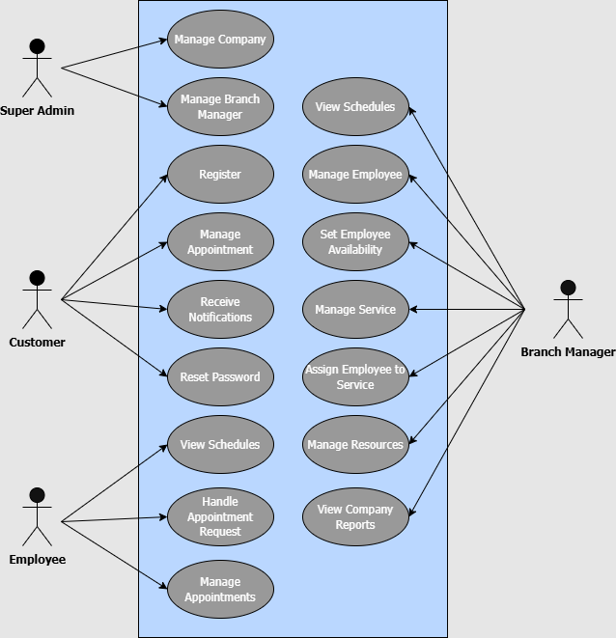

### Object model

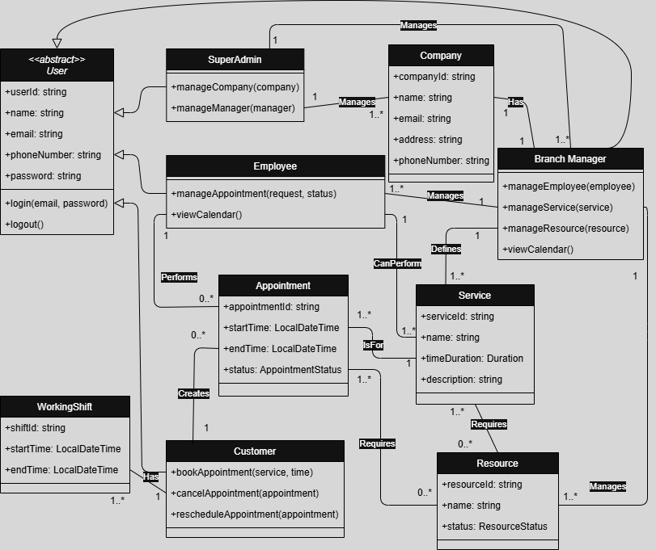

### Dynamic model

**Interaction Diagrams**

Create an Appointment Request

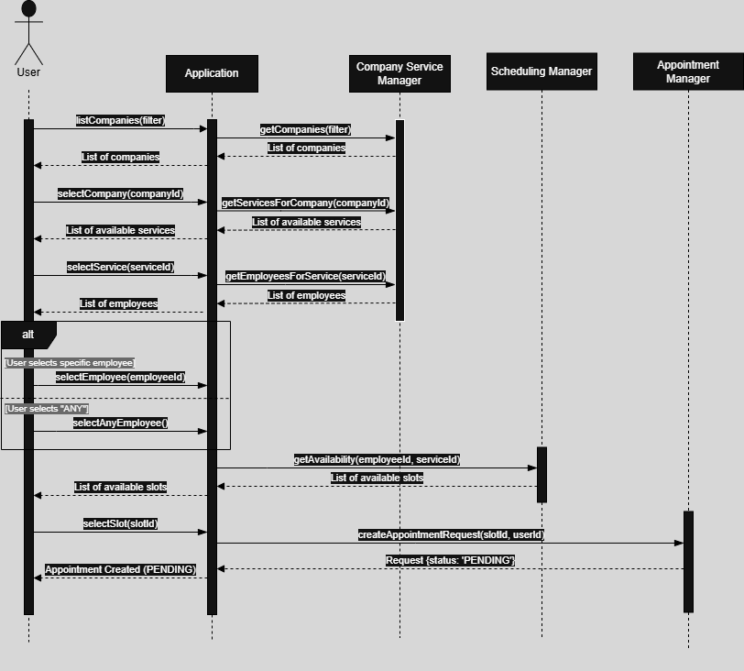

Handle Appointment Request

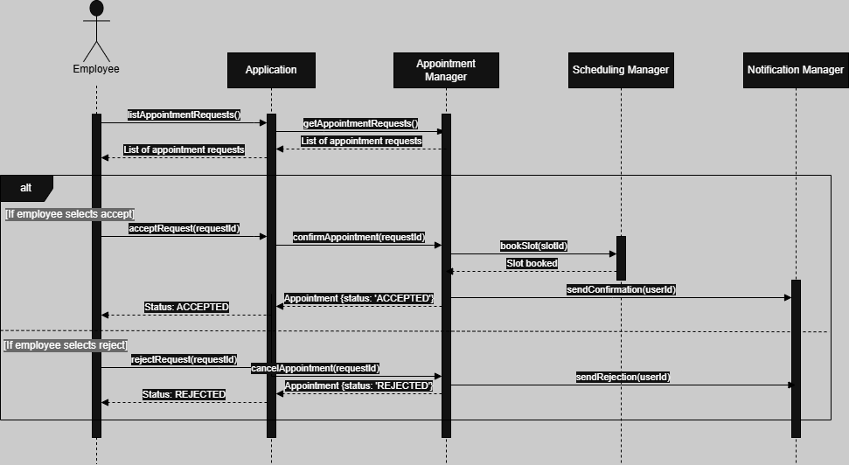

Set Employee Schedule

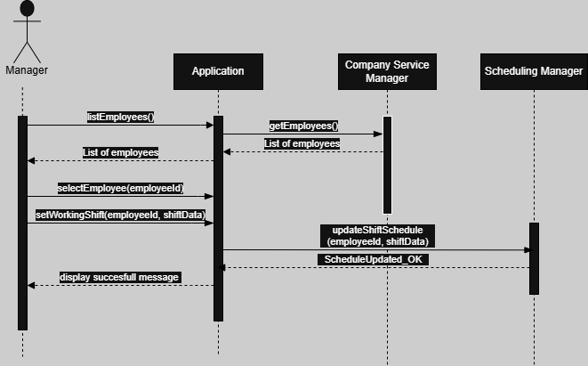

Reset Password

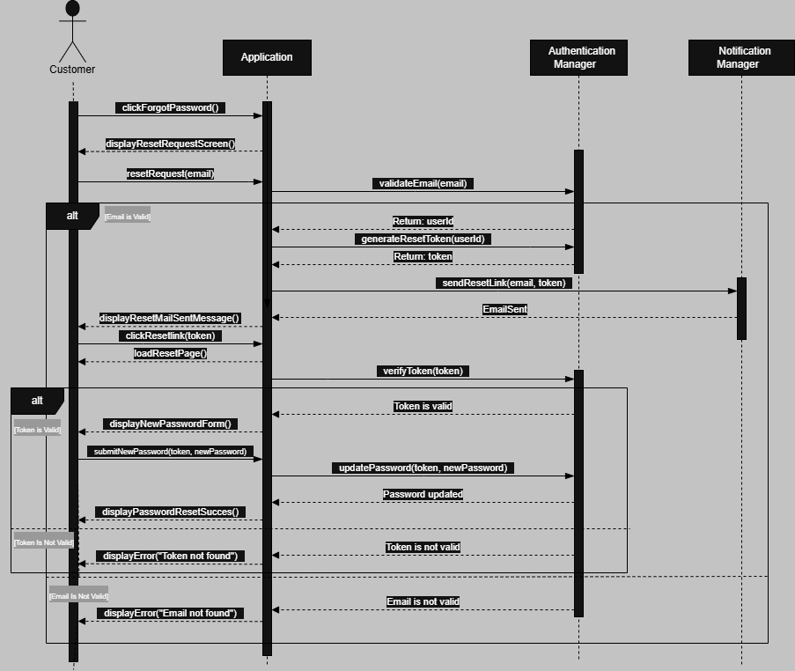

**State Machine Diagrams**

For Appointment

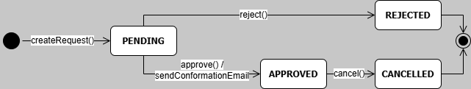

For Resource

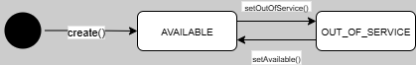

**Activity Diagrams**

Authentication

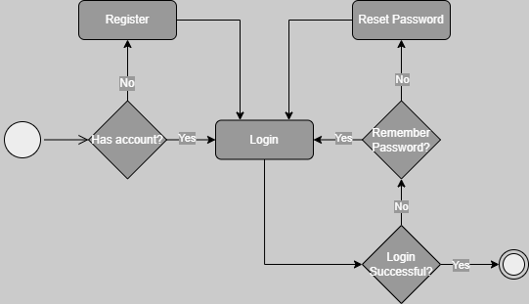

Customer Cancel Appointment

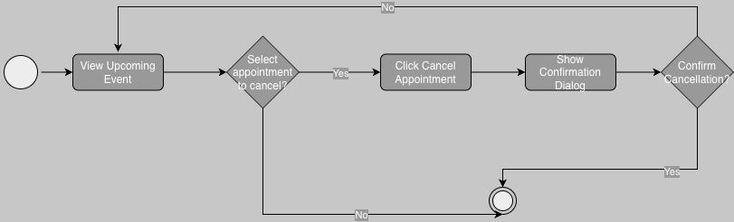

Branch Manager Sets Employee Availability



Branch Manager Configures Service and Resources

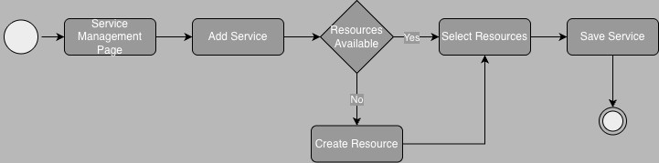

Superadmin Handles Company and Branch Manager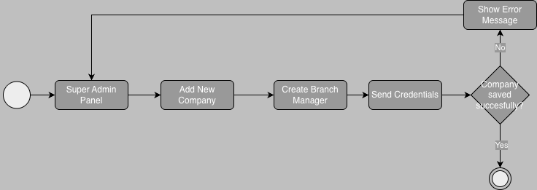

### User interfaces and Mock-ups

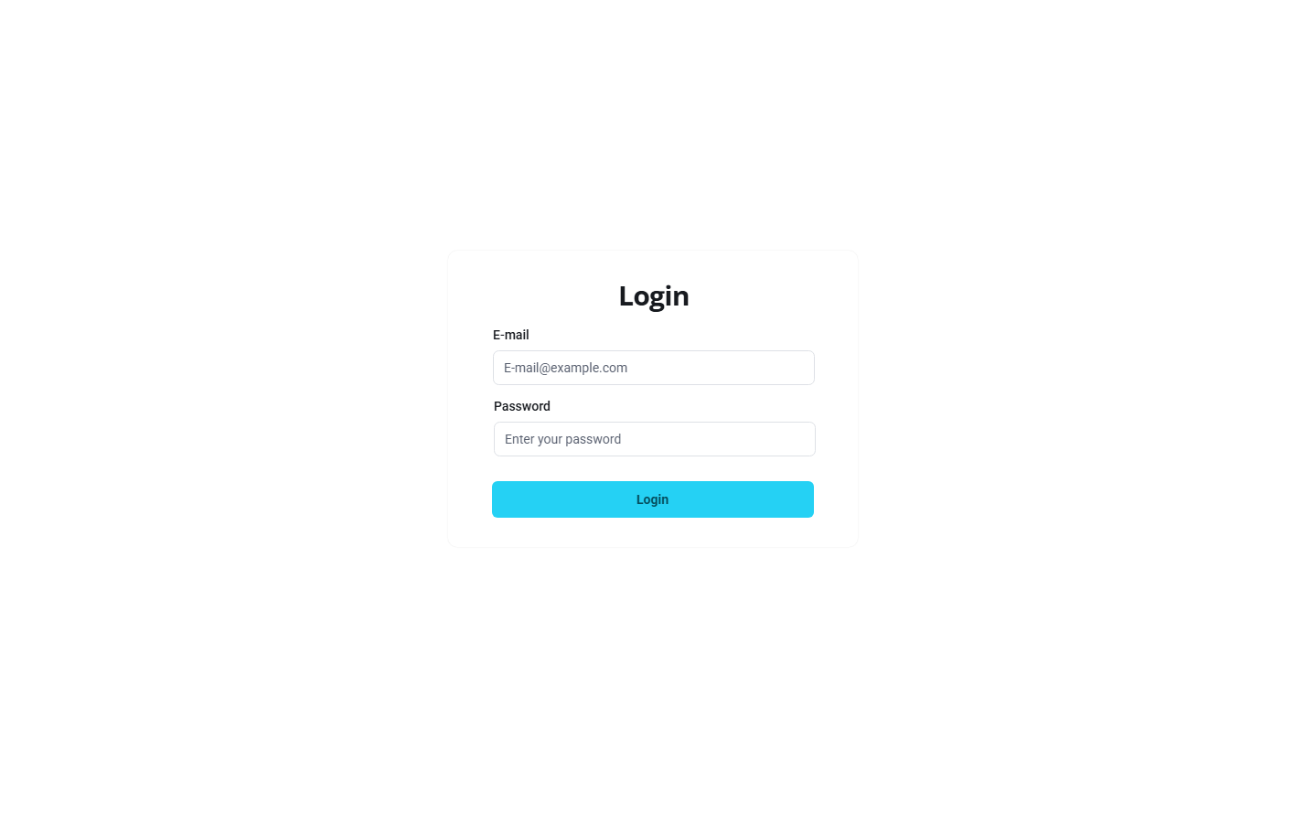

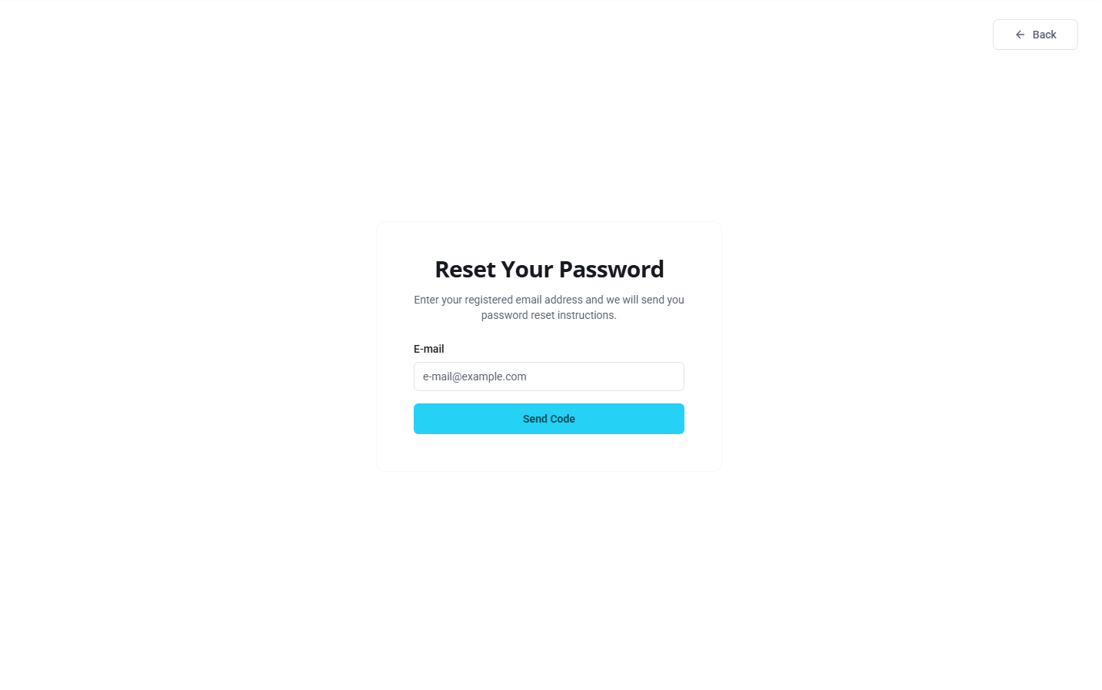

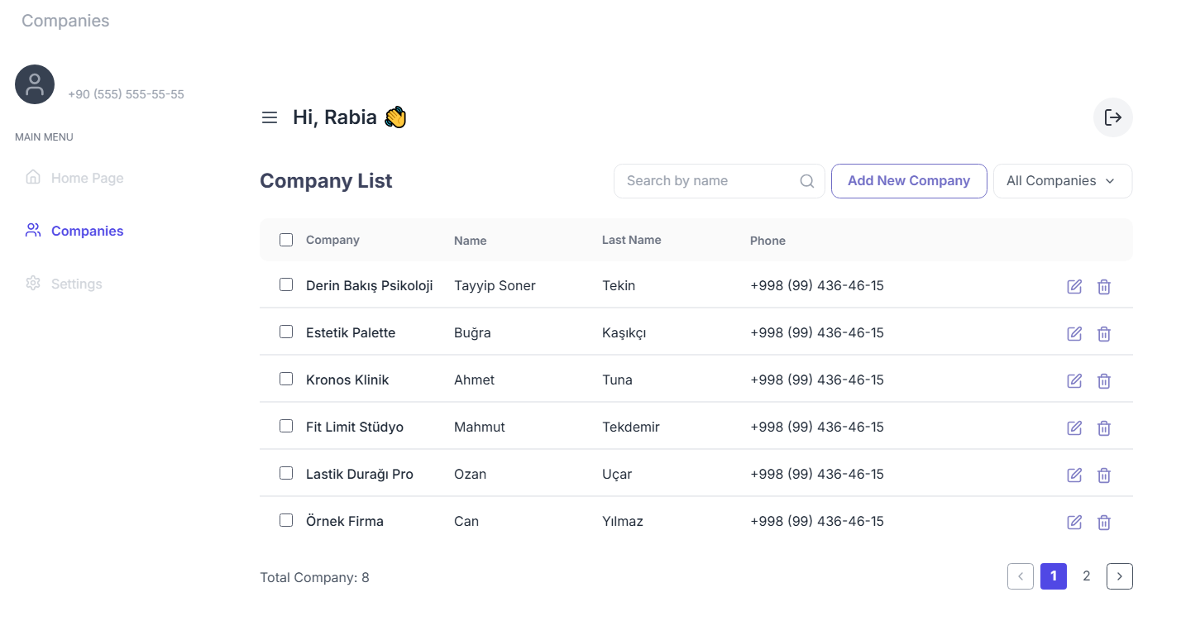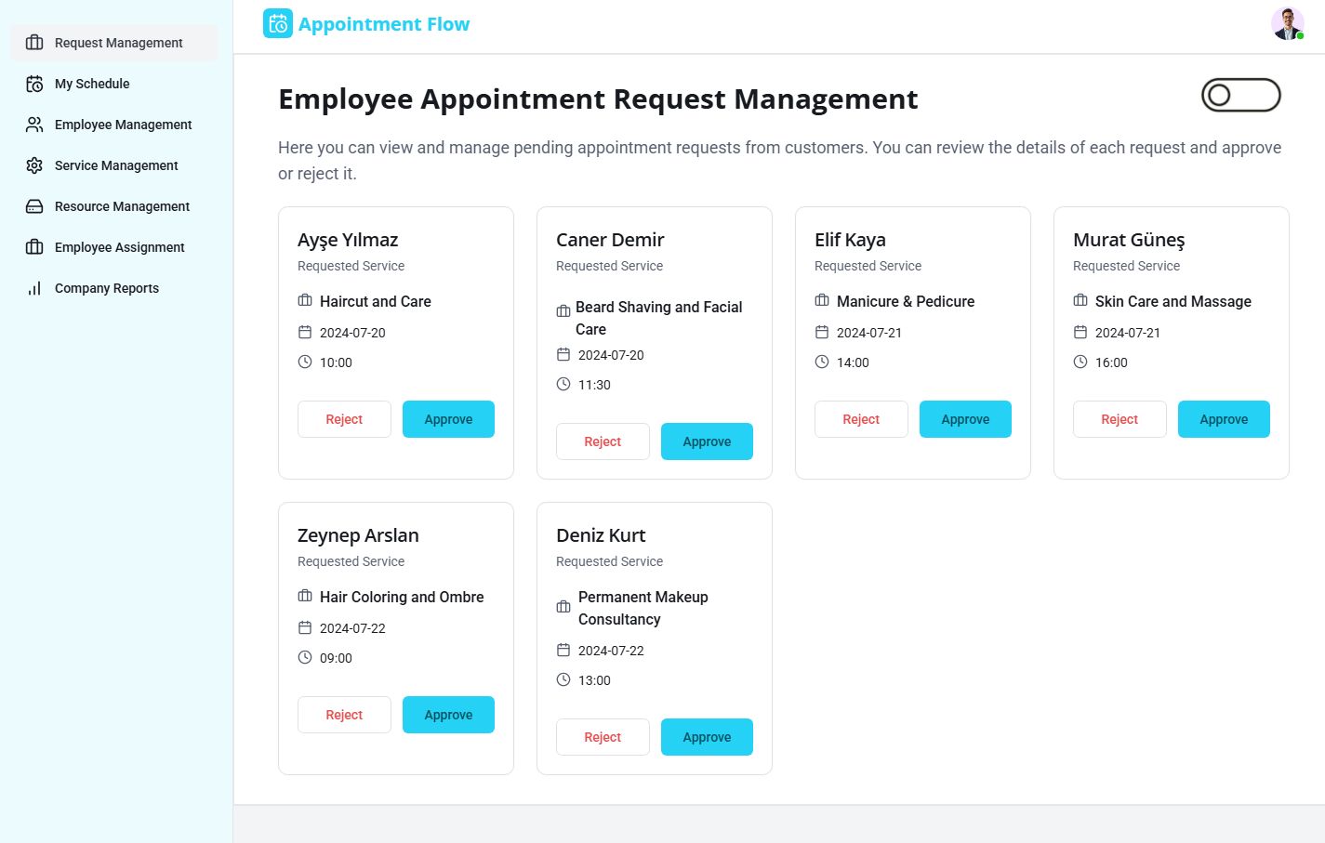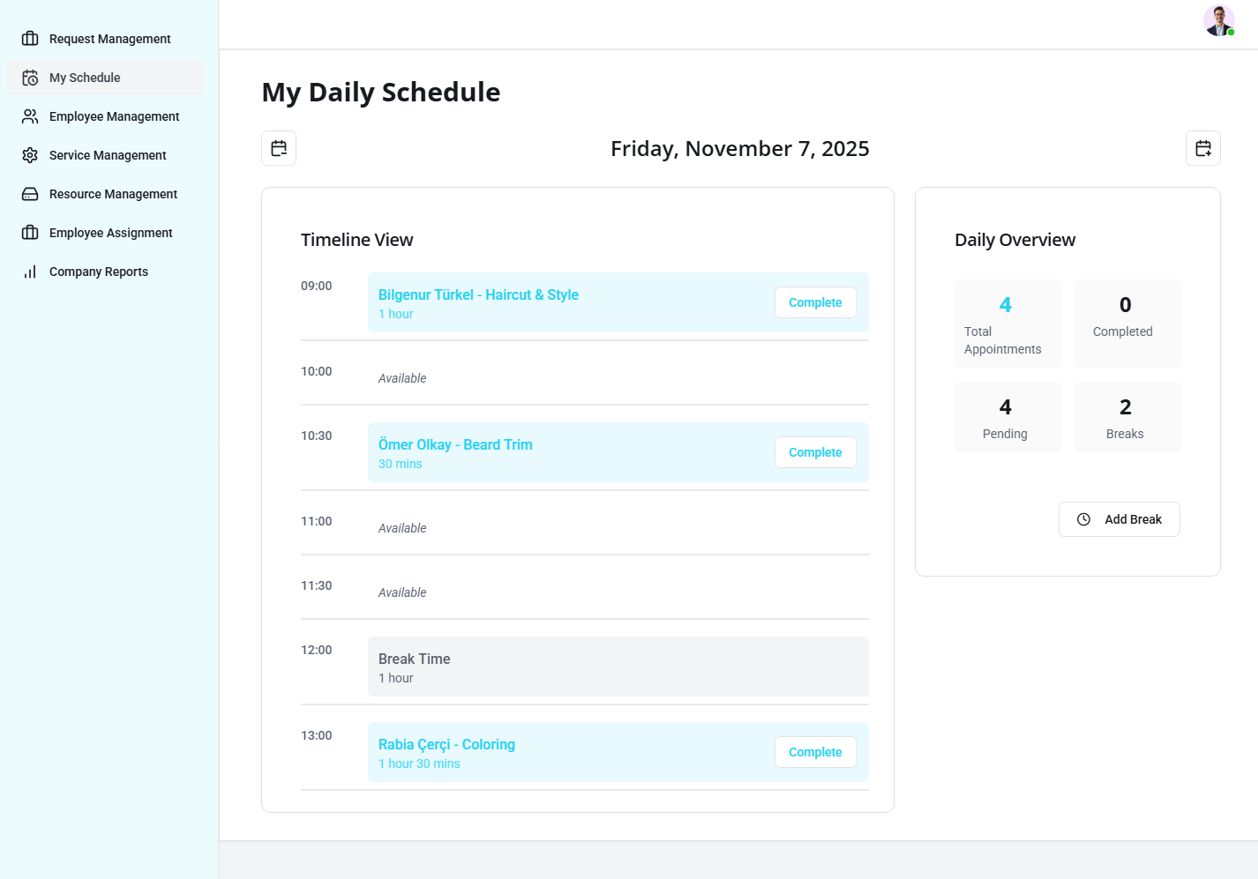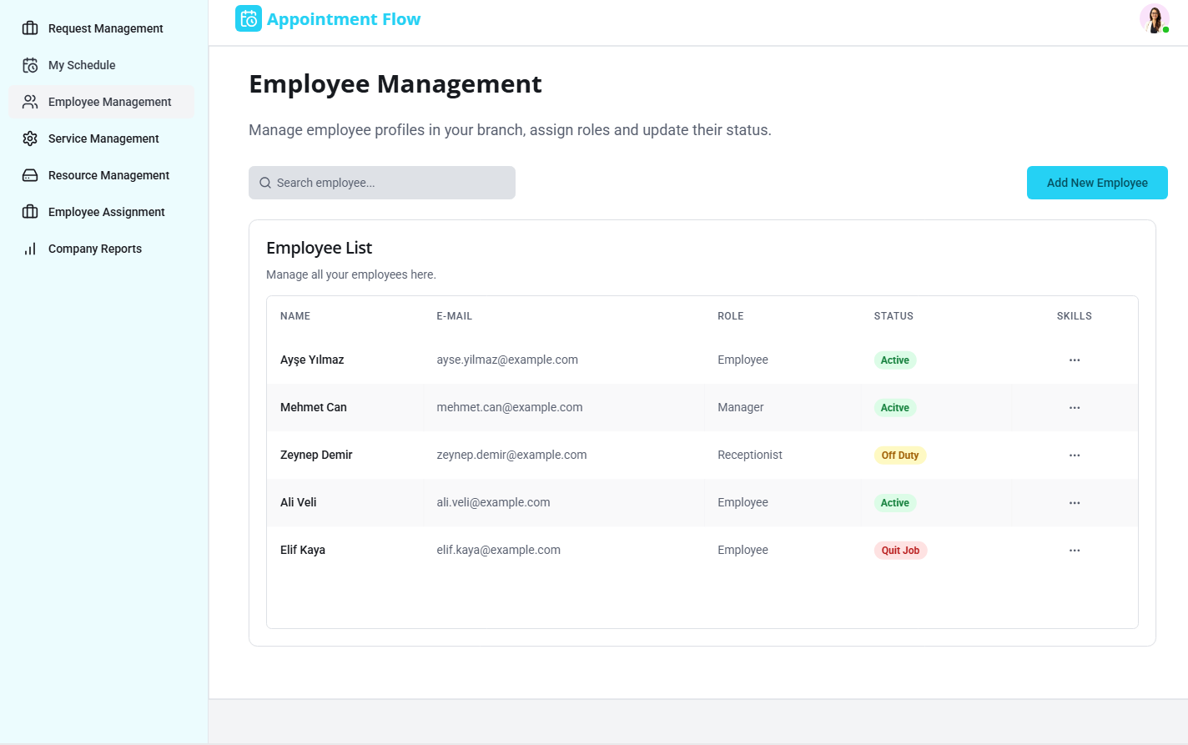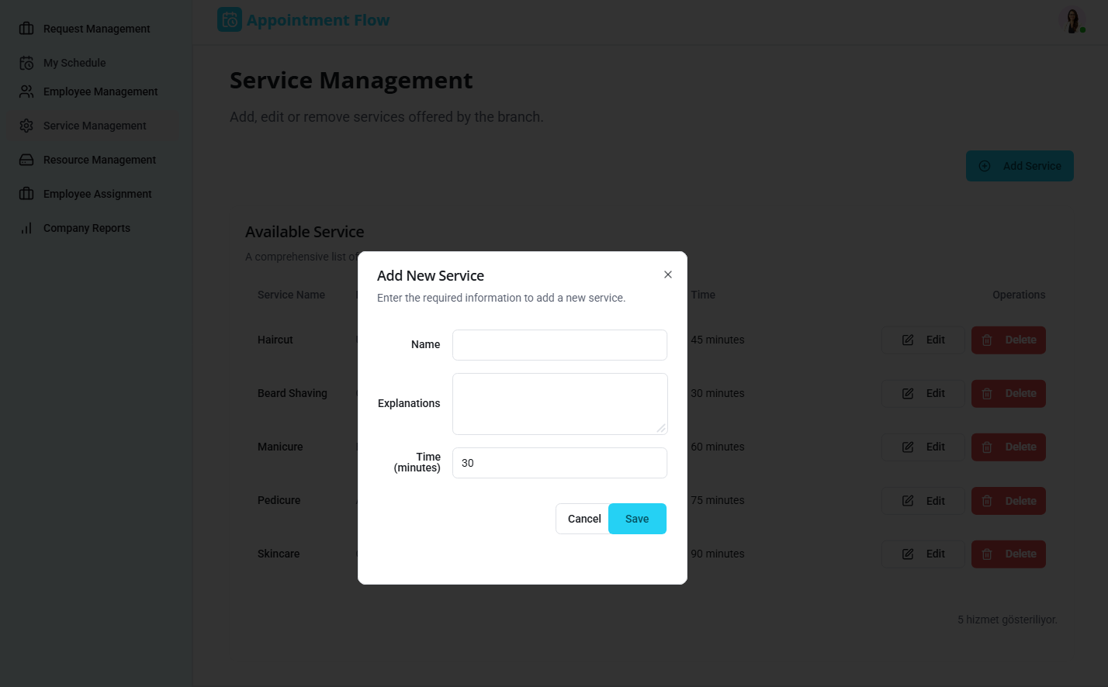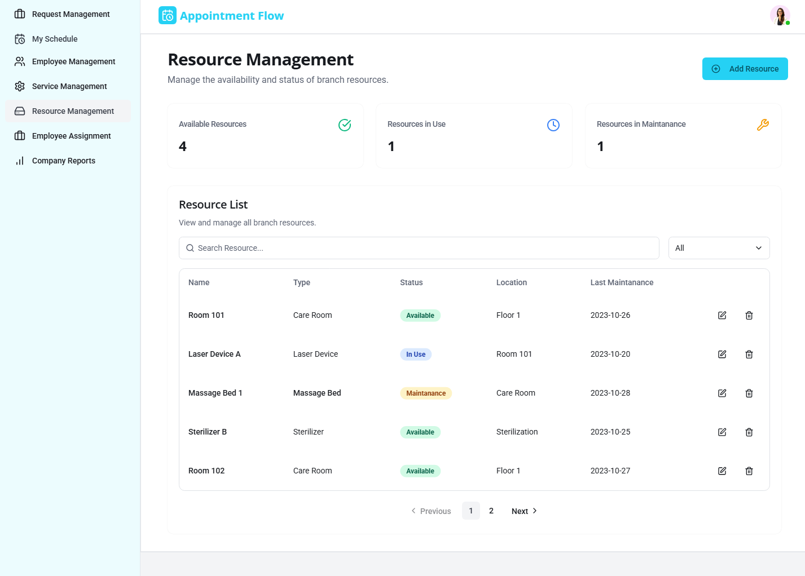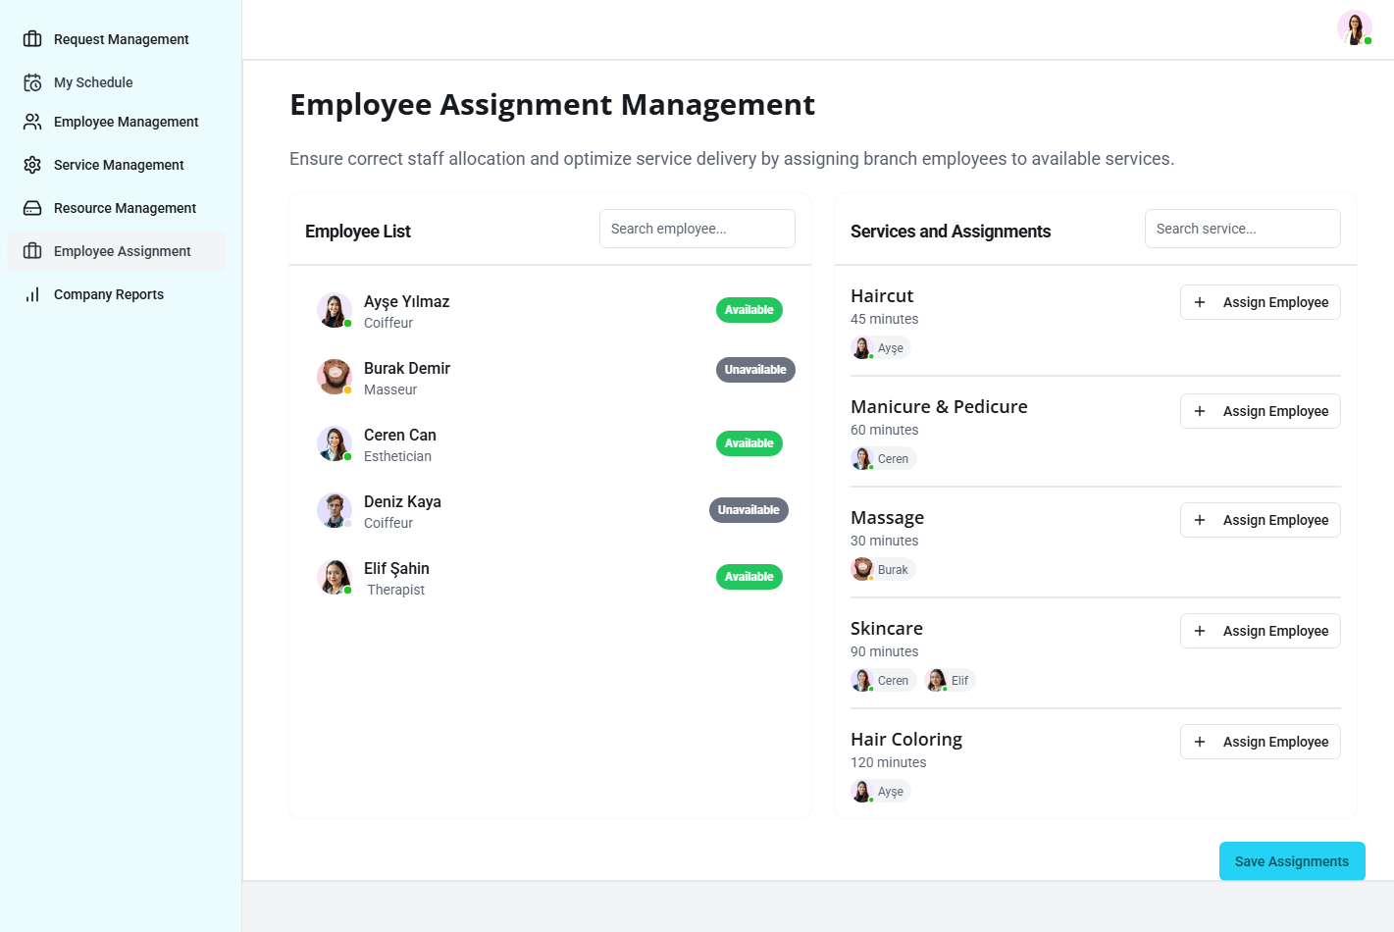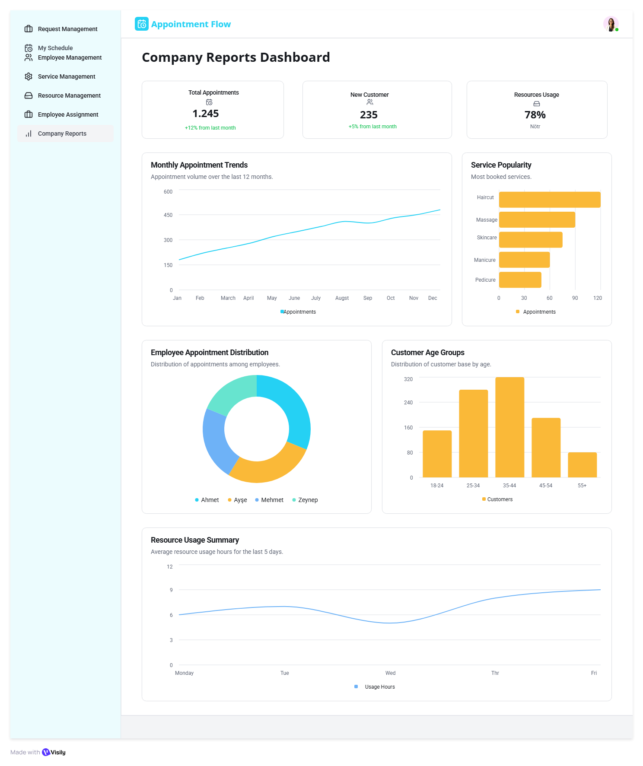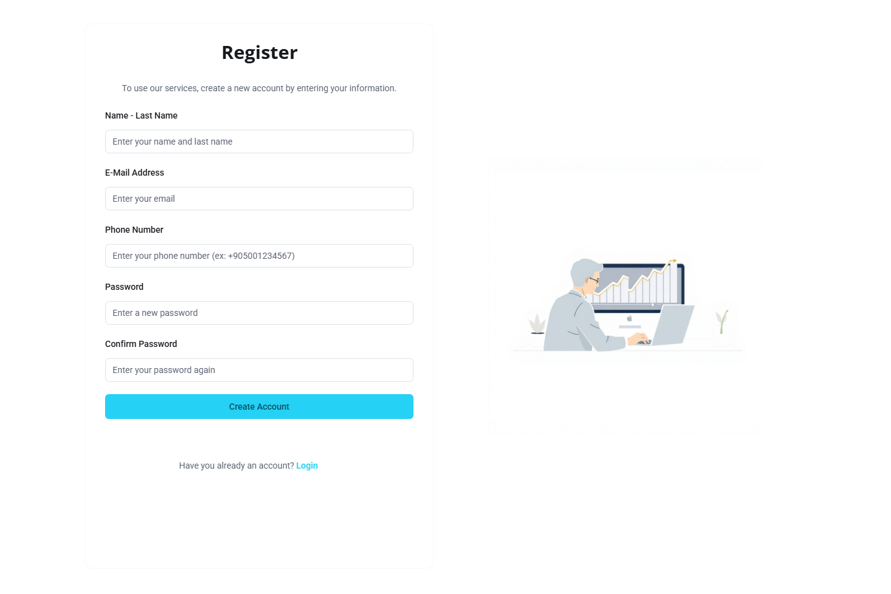<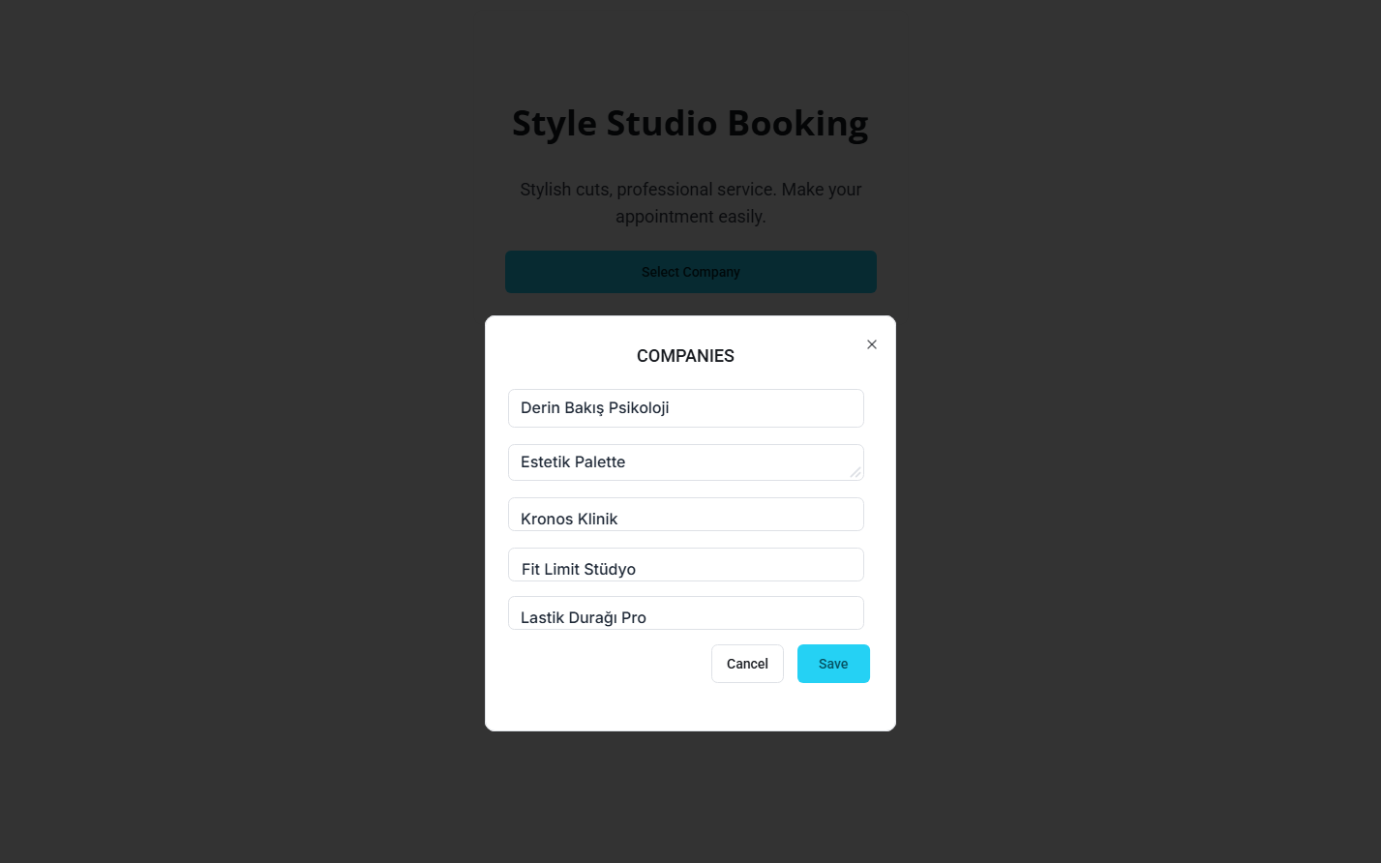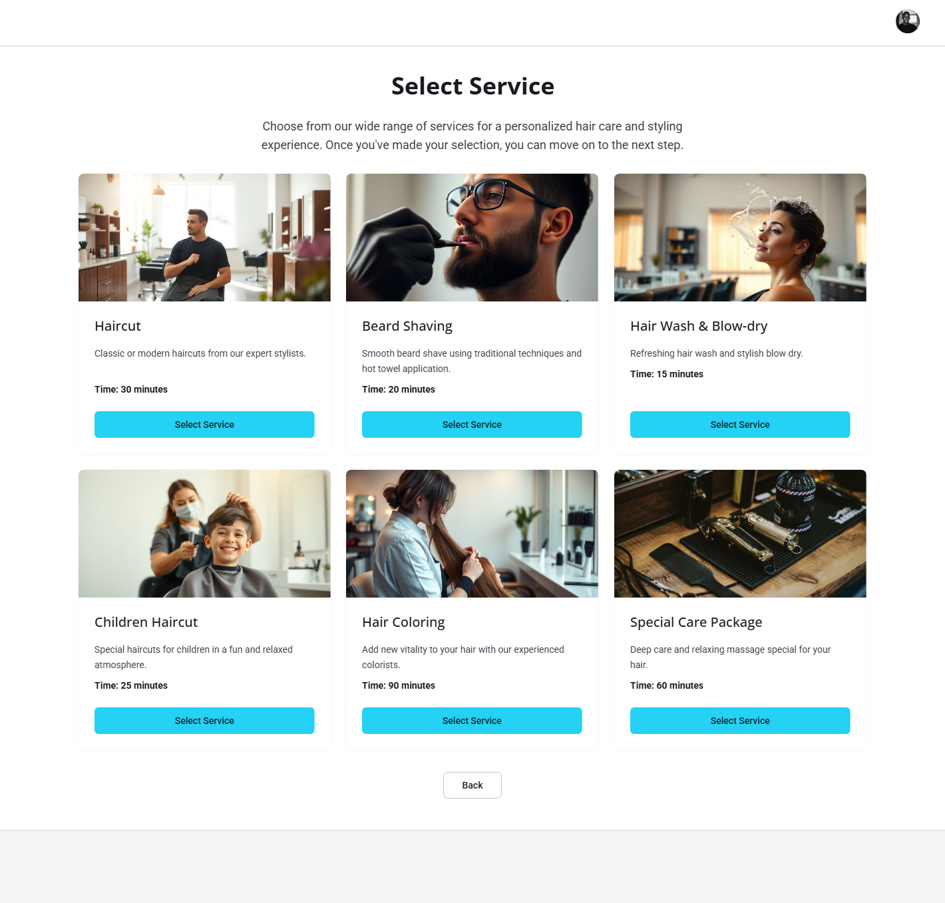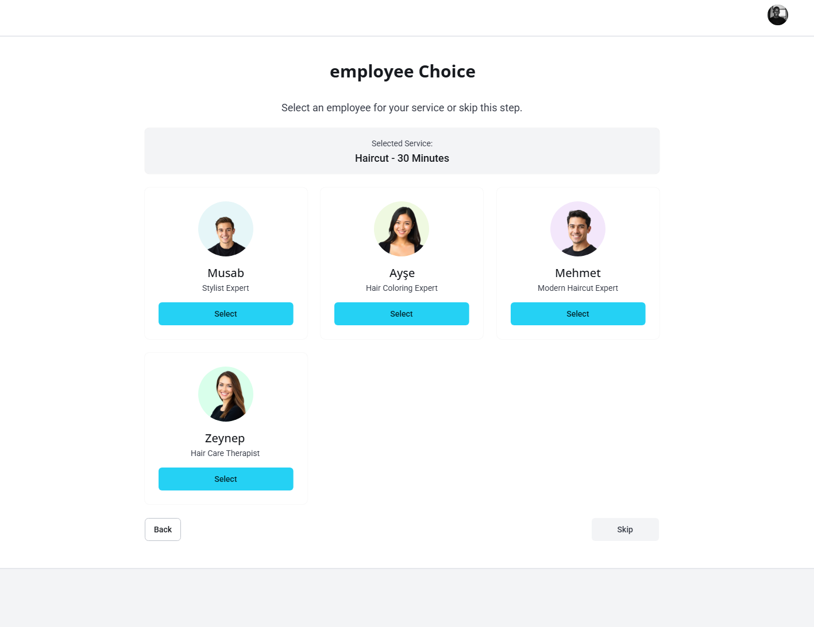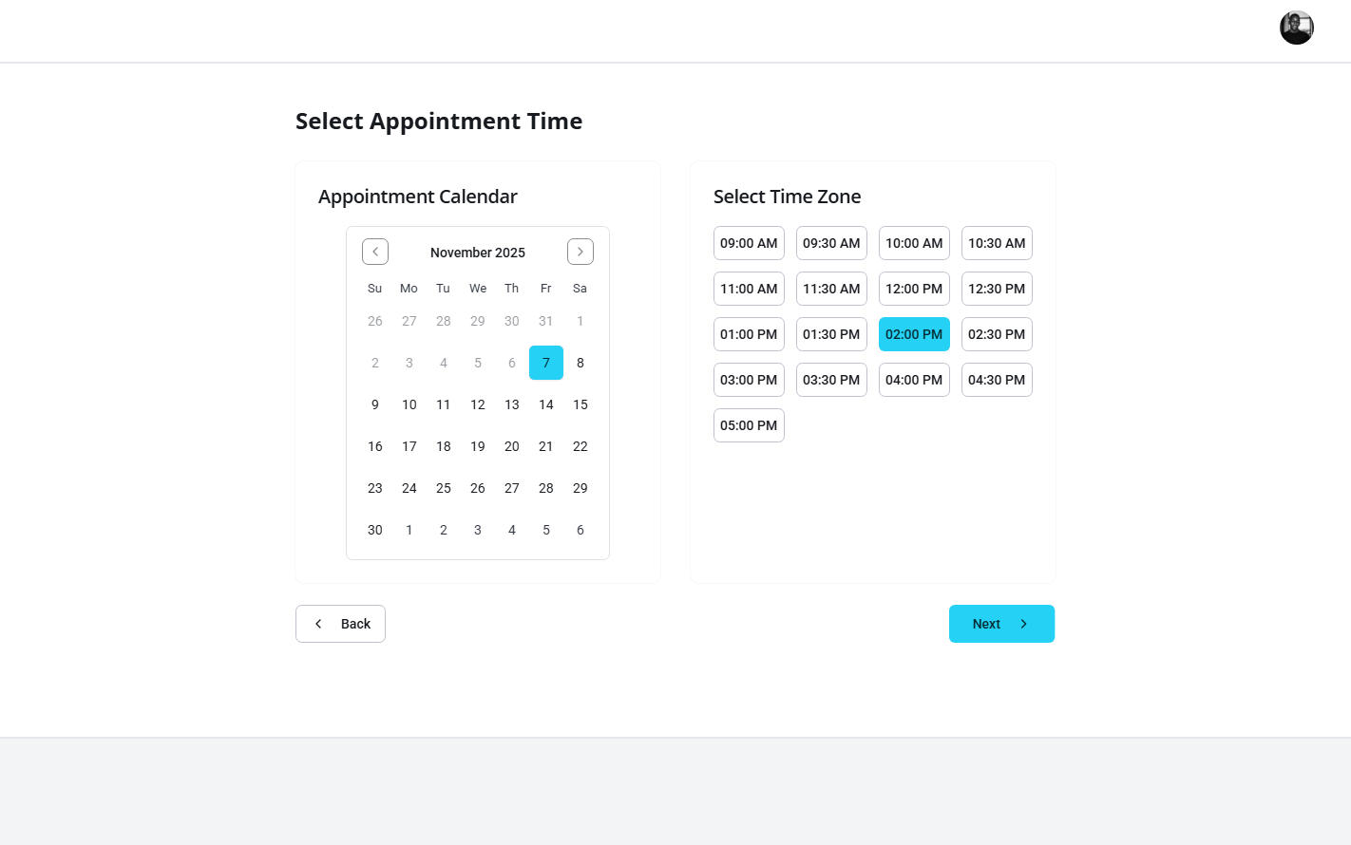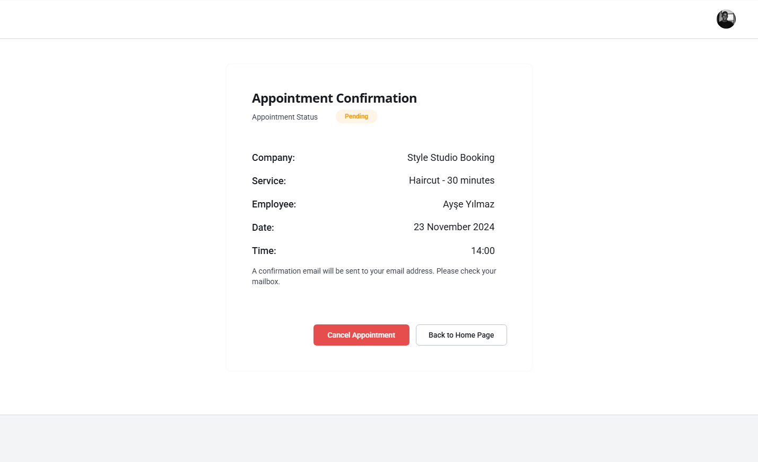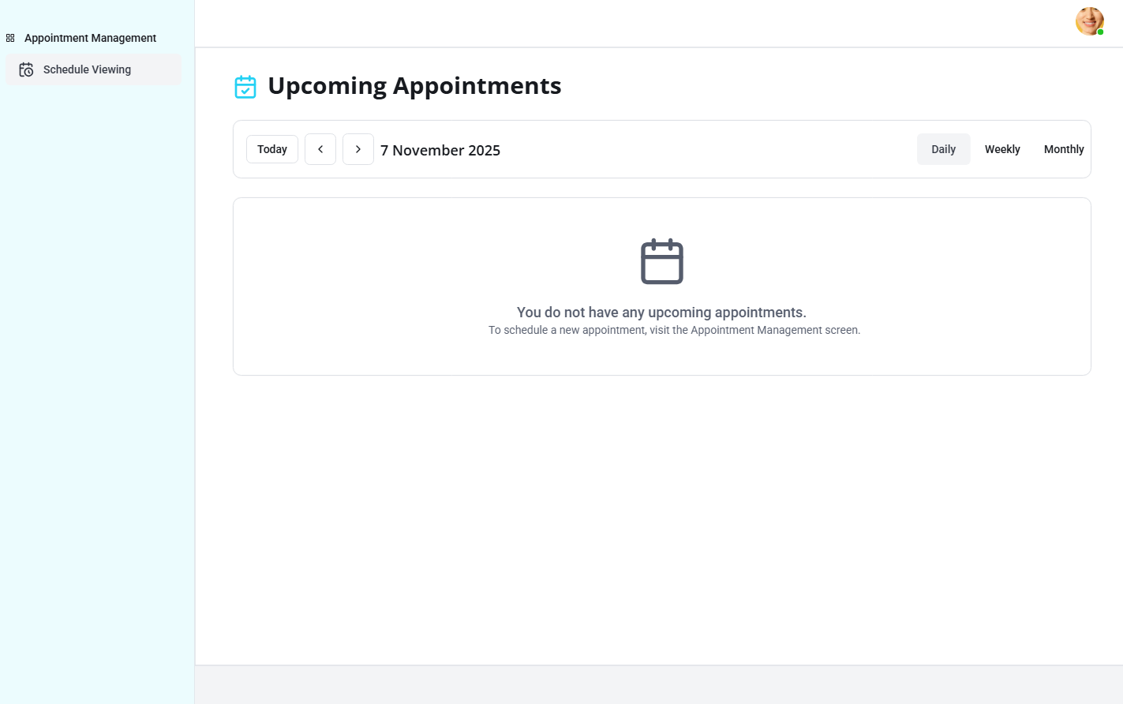

# Glossary of Terms

***API-first*** *A development philosophy where API contracts are designed and specified before implementation, ensuring modularity and parallel development (NFR-I-004).*

***Branch Manager*** *The system user responsible for managing a Company's operations, employees, services, and resources.*

***CRUD*** *Acronym for Create, Read, Update, and Delete—the basic operations for managing data entities.*

***Customer (Client)*** *The external end-user who books and manages appointments with a Company.*

***Multi-Tenant*** *An architecture where a single application instance serves multiple independent organizations (tenants), ensuring data separation (FR-SYS-001).*

***Out of Service*** *A status indicating that a Resource (e.g., equipment) is temporarily unavailable for booking due to maintenance or other constraints.*

***PENDING*** *The initial status of an appointment request created by a Customer, requiring subsequent approval by an Employee.*

***PWA*** *Progressive Web App. A web application designed to offer a user experience similar to a native mobile app, including offline functionality and device installation (NFR-I-002).*

***Resource*** *Assets or equipment required for service delivery (e.g., treatment room, specialized machine).*

***Shift Schedule*** *The defined operational start and end times for an Employee's working day (FR-MGR-002).*

# Traceability*metin, ekran görüntüsü, sayı, numara, paralel içeren bir resim Yapay zeka tarafından oluşturulmuş içerik yanlış olabilir.*